# Interim Submission Evidence of Contribution / Feedback

|  |  |  |
| --- | --- | --- |
| Description | Link to Evidence | Mark |
| Contribution to analysis, design and documentation | Final Report:  <https://github.com/MAL2020-Computing-Group-Project/TeamKiutBois/tree/main/Part%202/Project%20Docs/Final%20Report> | 30 |
| Contribution to implementation | Unity Package Assets:  [assets package.unitypackage](https://penisulacollegenorthern-my.sharepoint.com/:u:/g/personal/limhon_student_peninsulamalaysia_edu_my/Ec8B5slidRFKnYq8X8Pp4CsB2q4nbepmDo9UNhavFwHwHg?e=gU6Pth) | 20 |
| Contribution to LSEP | * Checking if the models are plagiarised * Check on the IEEE code of ethics while implementing our design   Final Report:  <https://github.com/MAL2020-Computing-Group-Project/TeamKiutBois/tree/main/Part%202/Project%20Docs/Final%20Report> | 20 |
| Evaluation | Self-Evaluation report link:  <https://github.com/MAL2020-Computing-Group-Project/TeamKiutBois/tree/main/Part%202/Project%20Docs/Individual%20Evaluation%20Report/BSCS2309535%20-%20DANNY%20CHAN%20YI%20XIANG> | 30 |

By submitting this document you are confirming that the evidence you are presenting here is your own work and that you understand a false or misleading claim can lead to action being taken against you in relation to an academic offence.

## Evidence

Evidence should take the form of meeting minutes (weekly team minutes, periodic client meeting minutes), commits on GitHub, allocated items on kanban board and/or documents created.

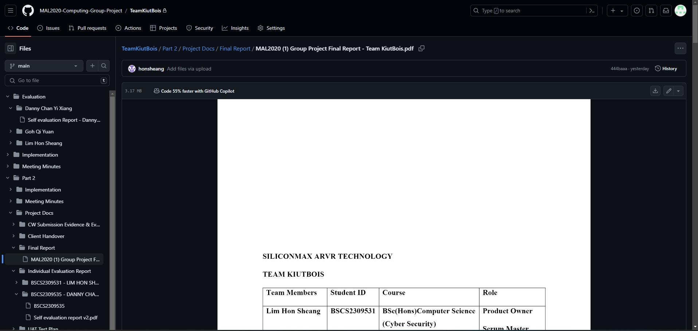

Figure 1.1

The final report is displayed in the GitHub Repo.

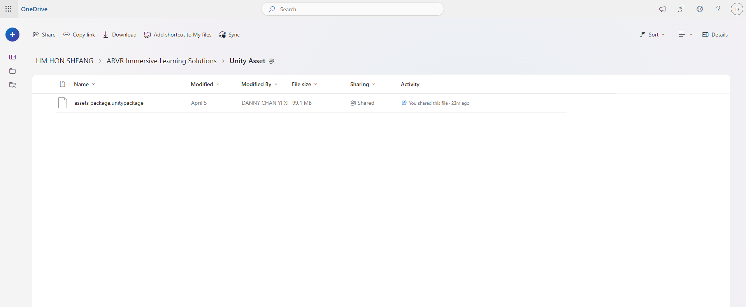

Figure 1.2

Unity Package Asset file is too large to be uploaded to GitHub. It has been uploaded to the OneDrive file for sharing.

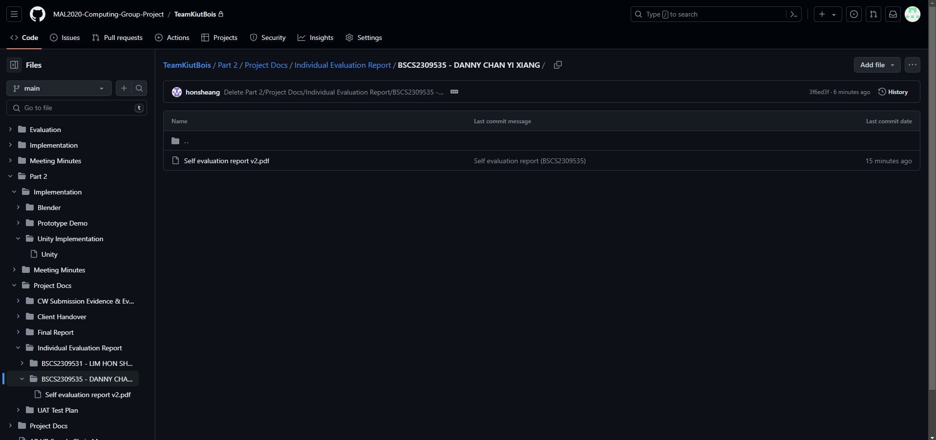

Figure 1.3

Self-Evaluation Report is uploaded to GitHub as evidence.

## Notes

Please write any notes in relation to the evidence provided above that you wish taken into account

## Evaluation

All the teammates are committed to their works and helpful to each other in the project.

Lim Hon Sheang, who is our team leader, have contributed many especially for client side and Blender in creation of the 3D models. He has written most of the documentations during the project phase and also communicate with our client regularly. Other than that, he is also committed to creating the 3D models in the Blender while making sure it is suitable for the deployment in Unity.